- Introduction
During 2015 – 2018, Thailand has shown a huge result with serious and significantly leveraged efforts to prosecute severe forms of Trafficking in Person (TIP) report. Eventually, the ranking of Thailand out of a watched list at Tier 3 to rise and currently stay at Tier 2 within 2 years. It is also considered as the best ranking ever for this country since 2010. One of big steps of success is the way to tighten up two keys of justice organizations including police and public prosecutor to work closely together. They can perform highly competency during an initial stage the pre-investigation as early as possible to ensure the necessary evidence be collected and preserved forensically in a positive manner. However, any weaknesses against the human trafficking case also should be determined before submitting all required paperwork and evidence into a court.
In many countries, backlogs happened in the courts or with a lengthy investigation and complicated interrogation absolutely delay prosecutions and slow the delivery of justice. Lacking adequate experienced officials or facing high turnover of those experienced prosecutors to handle time-intensive trafficking cases, that cause significantly delays might discourage victims from testifying or pursuing a case. At this point, the Thai government has finished to mobilize and move forwards comprehensive anti-trafficking efforts with the significant progress that make a difference in all aspects. One solution has been found good performance and effective output is a national agency creation namely TICAC.
The establishment of Thailand Internet Crimes Against Children, shortly TICAC Task Force, has founded since early 2016 with the purpose to tackle extremely worldwide concerned issues on new technologies adoption in facilitating the online sexual exploitation of children, and even sexual slavery. Those kinds of social problem increasingly escalate the demand for commercial sex tourism that absolutely unacceptable in Thailand.
In collaboration with agencies both governmental and non-government organizations nationwide and worldwide, TICAC received technical assistance training, SOP (standard operation procedure) development, and intelligence sharing to drive all field operation professionally. Two most topics usually deliver to all members of the agency expected being trained consistently are digital forensics and victim identification techniques. According to official statistics (until October 2018), TICAC has succeeded in solving the total of 117 digital facilitated cases related to child pornography (53 cases), child sexual exploitation (16 cases), and child sex trafficking (34 cases). Additionally, those outputs included 18 TIP (trafficking in person) with 80 percentage related to child pornography (CP) and child sexual exploitation (CSE) as multiple charges. Among those number, there are 126 perpetrators have been apprehended including 84 Thais and 42 foreigners. 48 individuals out of them have been certainly convicted with imprisonment sentences (Thailand Internet Crimes Against Children, 2018).
As mentioned above regarding various kinds of agencies worked together under TICAC’s missions, the only one of police university in Thailand namely RPCA short of Royal Police Cadet Academy also is a member with high performance in the way of providing laboratory supports and hosting vocational training programs. Almost three years a group of faculties at RPCA has been dedicating efforts to assist any requests in various forms to join TICAC’s expert teams in crime scene administration and evidence collection. This manner should be raised to discuss what exactly the role of police institutions to serve not only inside the academy’s boundary but also to give any assistance for local polices and national law enforcement agencies.

A national guardian toward a big issue
These days, online networking has exponentially generated data and information produced by social interactions. All content is not related to only text and pictures, but also clip video and full movie depending on its length. In this way, social media has a huge impact on how sexual crime committed and connected with both bad guys and innocent victims.
Cybercriminals have been changing behavioral pattern for committing crime taken apart online platform for the last three years. They tend to make the way to keep illegal files including child sexual materials both photos and movies into a place highly secured all the time, certainly cloud service like Google Drive or Microsoft One Drive.
These emerging patterns of criminal adaptation to go online and cross-border trafficking as well as present digitally facilitated CSE tendency creates a need for bilateral cooperation with country’s neighbors and international partners. It also requires capacity building of practitioner’s technical skills, information sharing, bilateral Police to Police in advantages of intelligence sharing and field cooperation. Moreover, case management guidelines should be considered as a key point to maintain efficiency during emergency responses.
Since early 2018, Thailand hosted two bilateral collaboration meeting between Royal Thai Police and Myanmar Police Force, and another with Cambodian National Police with the key topics about smuggling or illegal immigration issues along the borders. At this event, TICAC also participated closely and supported a specialist workshop on the public issues regarding online facilitated CSE for special unit law enforcement from seven countries in the region recently. Plus, TICAC is proud to be picking as a co-host among international agencies providing a training site for Indonesian Police special unit to share lessons learned, best practice, technical SOP skills, work system and structure with complex case studies investigated and prosecuted as remarkable practices.

Lessons Learned from TICAC
During a war of combatting various and critical forms of exploitation taken online platforms related to trafficking in human being and what the TICAC have achieved so far starting from proactive policing to utilise case management guidelines as stated below.
- Intensive victim identification process is currently crucial to seek support in all stages including investigation, prosecution, and adjudication in a case of exploitation of trafficking in persons, either for sexual or labor purposes.
- To implement an appropriate victim verification with interviewing effectively, the multi-disciplinary team (MDT) requires adequate evidence derived from fact finding both physical and online circumstances with preliminary investigation. If necessary, a particular MDT shoud make a proper judgement whether or not individuals are considred victims of trafficking exploitation.
- Based on a widely adoption of Victim Centric Approach, all live victim’s, after resused from emergency, should cooperate to disclose and share his/her victimisation experiences to be a key player in making a proactive policing by interviewing effective and successful. Normally, the victim is expected to provide assistance only when first responders and MDT have earned trust and confidence from the victim.
- Improving partnership by working closely with NGO and social workers to gain the victim’s trust and cooperation throughout the investigation, prosecution and adjudication process will increase the conviction rate of anti-trafficking cases.
- Working with law enforcement of neighbouring countries is required for cross-border concentrated in anti-trafficking efforts to be effective.
- Considering on both demand and supply factors on the trafficking in persons equation need sufficient attention in addressing issues on child sex tourism.
- The creation of a speialist agency like Internet Crimes Against Children taskforce or ICAC along with their twin Children Advocacy Centres (CAC) have capacibility to serve as a strongly demand reduction model to tackle child sex trafficking in the region and across regions.
- Immediately need for enhancing digital forensics and cyber security skills to develop digital intelligence analysis capacities of law enforcement personnel and, where it is feasible, to create particular specialised units under the goal of providing technical supports for holistic anti-trafficking practitioners.
- Finally, a need to develop and utilise anti-trafficking case management systems in terms of such guidelines or manuals to ensure all procedures met its standard of criminal justice practitioners’s each stage including investigation, prosecution, and adjudication capacities.
According to Wicharaya (2018), within the near future, Thailand is on the top of a nation being watched to enhance intergency, bilateral, and multilateral cooperation capacities to lead neighborhood joining the challenges in victim-centric prosecution efforts to efficiently identify and protect vulnerable victims and minors. Parallely, it should strenghen law enforcement capacities to detect and bring perpetrators of all prevalent forms of human trafficking to justice.

A common police academy among serious social issues
Royal Police Cadet Academy, shortly RPCA, is the one of police institution providing academic programs, both under and post graduates, and vacational training courses under organizing the Royal Thai Police. RPCA was literaly founded in middle 1902. At the first point, its area at that time was aim to establish a regional police school, not served nationwide. To find sufficiently suitable area, the academy has been relocated several times until eventually in Sampran city. Since lately 1956, the academy has served the Royal Thai Police as the main institution providing academic knowledge and practical techniques for its cadet and even police officers entirely the country for being who are able to support the public in general need in terms of public service and security.
Presently, RPCA proceeds the educational courses under the police cadet curriculum. It divides into most intensively three sections, including academic, police practical and extra-curricular. Not only serving educational a new generation of police, the academy has another goal to mold appropriate physical and morality characteristics into those young polices who will be appointed to commissioned sub-inspector after recruit in order to responding annually the demand of the Royal Thai police who will give an exact number of graduated cadets each year.
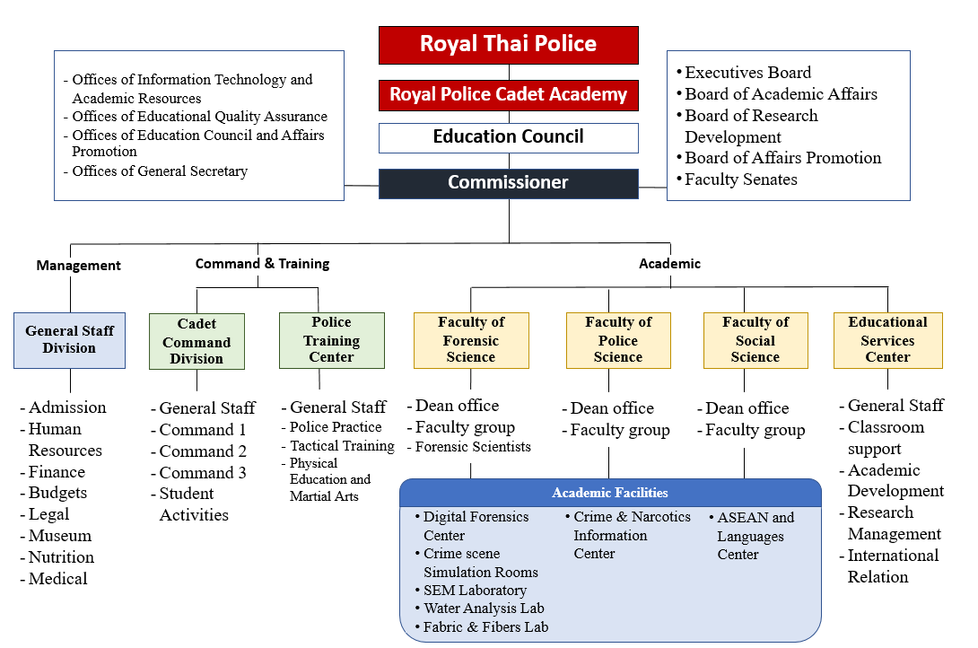
Figure 1 –Overall structure of RPCA
As a higher education organization, three characteristics out of academic approaches mostly focusing management, leadership, and creativity to fulfill one success. Apart from them, groups’ harmony include personality, health, and human relations are expected to maintain since admission until graduation and so forth. Additionally, responsibility for themselves and society, recognition of social services, familarity on budget management, and allocation of resources efficiently are the most part being trained in its curricular, the bachlor of public adminstration concentrated in police science, namely BPA.
For the administrative section, its structure is divided into three divisions, academic, administration and educational services. All of them are higly important in the development of young police. One of the most responsibity of these administrative divisions is to remain internal preparation upon transferring academic knowledge from the theoretical point of view to the practice. The faculties and top level officers are focusing to extrat the lesson learns from a case study or actual case that has already been resolved.
According to a former commissioner, Piya Uthayo, the policy ‘Head-Heart-Home’ or (H3) has still been the key perspectives to organized the academy with technology driven instituion. A cadet who be expected to graduation eventually come along with internal and external aspects once starting his/her police career. An inside part is relied on academic knowledge the cadets gathering during a journey entirely four years both in-class and in-field of training. In addition, a mindset also is a main point to be developing mostly from previous situations as a commander during life in dormitories and junior-senior relationships. Parellely, an external perspective should strengthen physical and mindset skill gathering from sport and out campus activities, particulary police tactical. Moreover, those new police are monitored to apply firearms professionally and relevant police equipment into incident response during daily life and emergency required critical response.

Inputs Forensic based approach into a Academic Program
To tackle the real issues in police career, the way to collect and preserve evidence at crimescene taken in the laboratory practice in science-based standards critically improve skills of modern crimescene management. Cadets have directly experience a real testimony may come from a lawsuit or hypothesis. In addition, this environmental class also provides an opportunity for students to familiar scientific processes sounded forensically, such as problem solving, hypothesis testing, experimental testing, error correction, and conclusions.
Currently, there are four science laboratories: (1) Scanning Electron Microscope (SEM) Laboratory, (2) Water Testing and Analysis Laboratory, (3) Fabric and Fibers Analysis Laboratory, and (4) Digital Forensics Center. All mentioned laboratories are used for both undergraduate and graduate programs. In addition to learning the standards for storing and analyzing various types of evidence, students also have ability to learn, screen, and store evidence at the scene. The scene lab records both the video and the risk to be both practical and correct. Cadet officer the next generation was expected to specialize in treatment at the scene. Both with common biometric materials and electronic evidence.

Intensive Digital Forensic Learning
The Digital Forensics Center, namely DFC, founded since lately 2016. This place could have awareness any visitor both internal and external participants with modern and technology based scientific perspectives. The center had maintained three objectives as following.
- Assisting region scientists in the term of digital procedure forensically rely on collected evidences from crimescenes. Moreover, providing capacities of acquiring a number of cases outside the academy. Since DFC was contributed hardware, software, and even knowledge in specific field like computer audit trails, online investigation, and cyber security -based topics. By a cooperation between the academy and Operation Underground Railroads (O.U.R.) foundation, as a global NGO, the center is aimed to assist law enforcement agencies across the country to rescue child victims away from sexual abuse and exploitation.
- Empowering young police having and improving technical skill in cyber security. Throughout 2017, 14 courses were taken and drove an intensive training within the digital forensics center in both lecture and workshop programs. Topics are several types in order to cover essentials in combatting cybercrime against children, including typical digital forensics, online investigation, basic of cyber security, victim centric approach, on-site and triage at crime scene, open-sources intelligence (OSINT) technique, etc.
- Consulting a student organization named “Technology and Cyber Innovation” by focusing into how to apply the center as a place to launch a campaign and collaboration with internal and external stakeholders like NGO and TICAC. The TICAC is stood for a name of an effective task force under Royal Thai Police has a great collaboration with both big company and international government agencies, including foreign embrassies.

Table 1 – Digital evidence and related cases conducted in 2017 entirely
No. | Nationality | Process | Charge | Evidence items |  |  |  | Total
 |  |  |  | Mobile | Tablet | USB drive | Computer
1 | Thai | Lab forensic | CP Possession | 4 | 0 | 5 | 1 | 10
2 | Canada | Acquisition | Child Sexual Abuse | 0 | 0 | 0 | 1 | 1
3 | Thai | Acquisition | Child Sexual Abuse | 0 | 0 | 0 | 1 | 1
4 | Thai | Acquisition | Trafficker | 0 | 0 | 1 | 0 | 1
5 | Thai | Acquisition | Trafficker | 1 | 0 | 0 | 0 | 1
6 | Thai | Acquisition | Child Sexual Abuse | 2 | 0 | 6 | 2 | 10
7 | Thai | Lab forensic | Trafficker | 3 | 0 | 1 | 2 | 6
8 | Thai | Crime scene | Trafficker | 0 | 0 | 0 | 0 | 0
9 | Thai | Crime scene | CP Possession | 0 | 0 | 0 | 0 | 0
10 | Thai | Crime scene | CP Production | 1 | 1 | 0 | 0 | 2
11 | USA | Crime scene | CP Possession | 1 | 0 | 3 | 1 | 5
12 | USA | Lab forensic | CS Exploitation | 5 | 3 | 14 | 3 | 25
13 | Thai | Lab forensic | Trafficker, CP | 1 | 0 | 0 | 0 | 1
14 | Thai | Lab forensic | Trafficker, CP | 1 | 0 | 0 | 1 | 2
15 | Thai | Lab forensic | Trafficker, CP | 2 | 1 | 0 | 0 | 3
16 | Lao | Lab forensic | Trafficker, CP, CSE | 2 | 0 | 0 | 0 | 2
 |  |  | Total | 17 | 4 | 30 | 11 | 62

Challenging the class with real circumstances
Recently, the Royal Thai Government has stated policy nationwide to strengthen on the development and use of information technology as an enabling tool in the development of the country. It focuses on the technology and computer infrastructure, especially the use of the Internet to spread to all communities. We noted that the government's Road Map requires people to easily access digital resources and adapt their technology roles. In addition to supporting the manufacturing sector, it is also imperative to develop the economy and society, along with environmental friendliness. The goal is to accelerate development into the digital era of Thailand 4.0.
Today, police officers face the challenges that come with social, economic and political change. The mission of the people is to expand into the tourism and services sectors that are the source of income. The development of leaps and free trade has resulted in more sophisticated forms of crime. Technological crimes and economic crime are challenging the national police force's need for skilled personnel, as well as modern technology tools that will be used to track traces and prove offenses based on modern technology.
The Police Cadet Academy aims to develop the organization as a lifelong learning institution for police officers and law enforcement officers. As a source of knowledge, standards need to be able to provide both classroom and distance learning through technology. Graduate students and for short-term training, institutions need to be the mainstay of police duty and the risk of lack of confidence in the law. Methodology And technical.
Enhancing skills in forensic science has resulted in increased confidence among police and students in simulated situations by removing lessons learned from the verdict. By the end of April, the Forensic Science Faculty had successfully completed a short training course in Digital Forensic for Investigators. The investigation team of the Thailand Internet Crimes Against Children (TICAC), together with a total of nearly 60 cadets and 4 students, jointly conducted digital examination and digital footprints tracing.

Adoption Technology Leveraging Police Work
As mentioned early about proactive victim centric identifiction should be discussing all over the top of public issues against sexual exploitation, one of disruptive technology currently namely Artificial Intelligence or AI is step in the front line as a powerful resource to answer the big question. A combination of image processing and machine learning to develop and supervise a computer witin a particualr nearul network would be the state of art in term of improvement crime control nowadays.
The face detection program for sexually exploited online victims and sex trafficking adopted image processing technology to reduce the workload of law enforcement officers in filtering and separating victims among thousands of files, particularly two hundred of them each case. The aim of this proposed study is to develop an opens source system provided confidentially for law enforcement agencies, particularly police force, to access and support in the process of victim identification.

With two keys featuring the system effectively improve the conventional process filtering manually each victim upon file-by-file after digital evidence acquisition from devices at crime scene collection. The first role is to analyze several sexual materials, or even regular pictures appeared human faces on them, those found on a copy of imaging after duplication forensically, then prepare with a good condition technically before going ahead submission into the system. The second role is to compare with social media profile pictures, all of them are public access.
To support the idea, Leqi Liu, et al. (2016) suggested the way to understand and design a system to investigate relationship between social media and personality should be under the term of phycological aspect. They designed the method to gather public profile picture into their provided system. Their assessment also combined with texts of tweets that profile instances performed recently. For data sets, the researchers collected from Twitter data which separated into two type including TwitterText and TwitterSurvey. Before starting image extraction, they conducted text analysis for grouping personality and age by processing at least three thousand posts each selected Twitter's user. For image works, they preferred to apply some techniques based on deep learning method, including Face++2 and EmoVu3, as the key features of facial related image extraction. Face++2 has the most ability to improve the system making accuracy with sampling facial presentation. For EmoVu3 was aimed mainly to train the system emotional detection expressing by faces on profile pictures. With powerful training model, they could supervise the system into certain categories: color, image composition, image type, image demographics, facial presentation, and facial expressions.
Social profile pictures detection is an important technique for finding and comparing potential victim taken online. In machine learning techniques, the features are expected to compare an acquired image to current profile pictures appearing online.
To detemine about what a kind of good dataset, the first thing is sampling group deriving from a variety type of media files must have a human face will use for training and testing sets. Suitable features after significant supervision many and many models are selected by applying notable selection techniques. Then, the model will be up to the next stage the comparison process. The main techniques to complete that comparison including decision tree, logistic regression, multilayer perceptron, and related image processing algorithms.
Face Detection is a critical process to find a person's face from an image or video, then providing as a processed image with an expected human face for the next step. After basically detection, the proper images with human faces is ready for next algorithms. There are several ways of detecting faces today. The good face detection algorithms help to identify the faces precisely and quickly. One of the most technique is Viola-Jones method. This algorithm offers a way of presentation called intergal image. It is supported processing and analyzing features. It is upgraded based on AdaBoost which has a classifier function effectively. Its cascade feature also extracts non-relevant background out of the objective in the picture.
Face recognition consists of the key aspects of capturing a face, separating it from the image, placing it face-to-face, capturing facial features, and then comparing it to the database. This process requires a large-scale dataset to train a software. For instance, Facebook has taken over four million images of four thousand people at least to practice a new way the powerful deep neural network. One key feature is to draw up to a three-dimensional model to align the face to a new face.
For good results, a simirality comparison as score calibration feature withint a desired sytem that is expected to be accurate is required a very large-scale data set for training modules. This study was selected from the Social Face Classification field (SFC), and then examined with a database of Labeled Faces in the Wild (LFW). They have ability to detect accuracy up to 97.25% near human detection at 97.53%.
Figure 2 – Proposal of workflow inside the face detection and recognition system
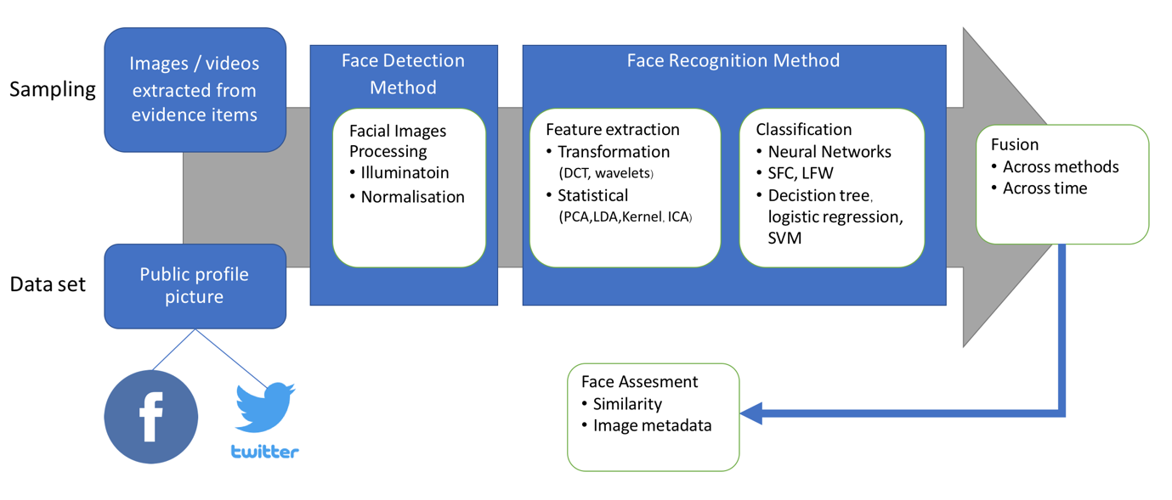
The above illustrator as another suggested instance demonstrates how the critical process work within this study. Image data will get from two distinction. The first source is the collected evidences which are digital devices seized from crime scence and found a number of sexual materials inside. Another data set is from public and online provided sources. Facebook and Twitter are the key role of social network platforms that the researcher prefer to examime an experiment. Then, the provided images will be input into the desired system staring with the first stage, face detection method. After cleansing data, the images will bring to the next processing called face recognition method. Now, the images will be traind and supervised by neural networks and classified with SFC and LFW. Before analyzing assesment, the images will be re-investigate in the stage of fusion by across methods and evne time matter. Therefore, the system will provide a level of similarity related to each profile case. The researcher, also as an full-time law enforcer, has an effective work-system to identify potential victims on online sextortion.
Hence, a comprehensive training set and data modeling that have high competence for verification known victims with unknown individuals appeared in extracted images and videos from digital evidence. The system also provides a score calibration with effective techniques as a measure for assessment and guide clients with sufficient decision support feature. Hence, they are with highly confident to prove actual victims in the real case before submitting all empirical evidence to charge the offender.

Conclusion
To fix the problem of anti-trafficking in persons with sustainability need to understand the whole nature of it into two dimensions of economic aspects. On the supply side, the police operations have to be strengthened by targeting the ‘Big Fish’ rather than small groups with the results in the detections, prosecutions, and convictions of influential and organized human trafficking syndicates. It also comes with lengthy incarceration sentences imposed by the courts, together with asset forfeiture of criminal proceeds. On the demand side, the creation of an underlying agency, for example, TICAC task force must increasingly focus into investigating child pornography (CP) and child sexual exploitation (CSE) related crimes as well as sex trafficking towards online sites.
Many decades, the RPCA is raised as a prototype in the production of commissioned officers. If they are defective or incomplete, the things produced are blamed and ineffective. Police all over the world and every single class often have problems dealing with people's interactions, including misuse and distortion of justice. Throughout the 117 years, this institution has been around Thai society for all ages. The police officers were deeply implanted in the school. Discipline Training and importantly, mind control, recognizing human rights and maintaining order.
Over the course of four years in the bachelor's degree in public administration, all students are tested for their physical, mental, and intellectual endeavors, regardless of whether they are male or female. Supervisors or followers must obey orders and make informed decisions based on accuracy. On the other side, those people must go through a period as a supervisor or a leader or team leader who must have a determined, courageous mind, and decisively decisive intellect and adherence to morality and virtue. This crucible has proven to be effective and effective in serving Thai society for peace and humanity or humanity. The principle of fairness must not be biased or prejudiced.
Justice is the primary duty of the Thai police, so the police academy is committed to creating a better society. Expertise, as well as strict confidence in law enforcement, based on proof of evidence and hearings on court hearings. If the police are the main body of law enforcement in the country cannot stand on the right ideology to enforce the law and bring the offender to justice, the society may lead to instability and resulting in. Great damage. For this reason, every cadet is cultivated over a period of 24 hours 7 days, recognizing justice based on testimony proven and punishing non-innocent offenders.
The current issue of sexual crimes is complex and technology-driven to facilitate the offense in a variety of ways. One of the most commonly used forms of abuse is the uploading of data, images, and videos that are sexual activity between victims and criminals. Next, they will be published on specific social media that provide features to keep all sexual content privately, for instance, a closed or secret group. That limited access from non-permitted people who did not pay for viewing or downloading those illegal files. This amount is worth a lot each year. One of the toughest challenges for police officers, besides tracking financial paths, is the identification of victims and sexual victims in large numbers of media and video. However, the advancement of image processing technology under Machine Learning can be developed to reduce the burden and help the staff make better decisions. When a victim has been sexually assaulted, he or she can assist the police to confirm the culprit and prosecute it. For this reason, the law and punishment are strictly enforced to the right offenders.

Recommendation
One of traditional police workflow is leveraging and responding directly to crime fulfilling with digital evidence in the real world. Machine learning is used to solve real social problems through the development of image processing systems with victims. The officials can apply this project as a particular tool in the near future immediately with routine work to do every day. The organization has a powerful and ready-to-use database that is shared with other units or stations, both inside and outside the organization.
Facial analysis system, a combination of face detection and face recognition, could adopt into real-life work for law enforcement agencies in order to combat internet crimes against children across the globe. South East Asia is a lure spot area for online pedophiles and even cybercriminals who prefer to commit a crime against minors, particularly innocents and young people. Many tourist attractions in Thailand still are the better place for bad guys to groom girls or boys through the cyberspace, mostly social media platform.
Although Facebook and Twitter are represented as the most two of five social networks popular in Asia, especially Thailand, each country should establish legally process to deal with international companies in order to request assistance towards social problems taken on online platforms. Not only western offender use to lure younger individuals, but also local offenders also loved to spend around the social networks to perform a fancy chat, then might go deeply with sexual activities at last.
If local investigators have the problem-based solution to assist them verifying victims both face-to-face and online situation, it would be a benefit to our public security by getting an urgent response. Face detection feature will support forensic examiners to filter a ton of photo inside digital evidence to result with potential victims and their faces. Then, face recognition comes in the place to suggest the official users classifying and assessing similarity related to their victim’s profile case work within the paper folders comparing to a result from online-based neural networks as one remarkable technology in the term of Machine Learning.

References
Wicharaya, T. (2018). Mobilising Victim-Centric Anti Trafficking in Persons Efforts: An Interim Report from Thailand. Presentation at 2018 ASIS Thailand Internatinal Chapter, Bangkok
Uthayo, P. (2017). Smart Thai Police 4.0. Retrieved from http://www.rpca.ac.th/ images/images/button/SmartThaiPolice_4.0.pdf
L. Liu, D. P. Pietro, Z. R. Samanni, M. E. Moghaddam, and L. Ungar. (2016). Analyzing Personality through Social Media Profile Picture Choice. Association for the Advancement of Artificial Intelligence, Retrieved July 31, 2018 from http://wwbp.org/papers/persimages16icwsm.pdf
Thailand Internet Crimes against Children. (2018). TICAC Task Force Bulletin and Annual Reports from 2015 to Present. Retrieved from http://ticac.police.go.th
Thailand Internet Crimes against Children. (n.d.). Why’s TICAC? Retrieved from http://ticac.police.go.th/
Royal Thai Police. (2017). Police Reforms. (copy).
. (2017) Educational Strategies of Royal Thai Police between 2017-2036. Retrieved from http://edupol.org/eduOrganize/publicDoc/strategy/Strategy HQP/2018/01.pdf

